**AXIAL PISTON PUMP MODEL**

ADVANCED FLUID POWER

HOMEWORK 5

DONE BY:

ADONAY, MAHMUD, RAVI

SPECIAL THANKS:

DR JIM VAN DE VEN

**Axial Pump Memo**

Axial piston pump is a type of positive displacement pump which has a number of moving components like axial piston that transfer pressurized fluid from one port to another. Each piston has a slipper assembly that moves tangentially around the swash plate because of the rotation of the pump barrel. The rotating pistons are supported by a swash plate, and the angle of the swash plate determines the piston stroke. The swash plate is at an angle to create a flow rate and, therefore, the displaced volume of one piston varies because of its axial motion within the barrel during one revolution. The flow through the pump depend on displacement (D) and speed of pump (), and given by equation,

Ideally, input power must be equal to the output power, i.e. fluid power of pump is equal to mechanical power of motor and the torque is represented by,

In practice, there are hydraulic and mechanical losses so the ideal flow equation must be modified. These losses depend on speed, pressure, clearances, seal types, materials, fluids, etc. Figure 1 shows a schematic of an axial piston pump indicating various flow leakage paths that contribute to the total flow loss. To determine the flow into the pump and out of the pump, it is necessary to consider suitable flow-control volumes within which the flow-loss terms interact, as shown in figure 1.

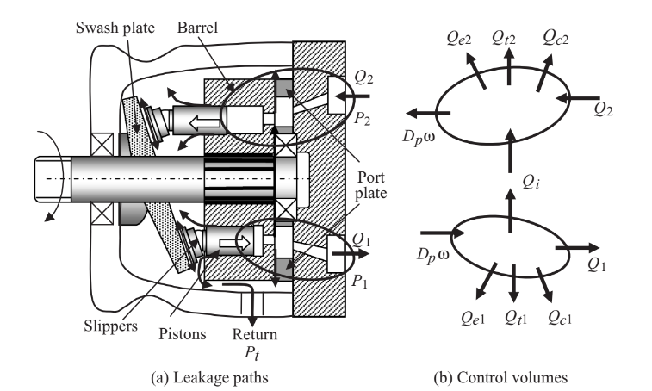

**Figure 1** Schematic of axial piston swash plate pump [1]

There are other sources of energy loss due to viscous friction, bearing friction, etc.

**Objectives:**

* Derive equation considering all dominant energy losses
* Define pressure dynamics of pump for the simulation
* Model an axial piston pump to compute volumetric and mechanical efficiency
* Determine the parameters affecting efficiency

**Assumptions:**

* The inlet and discharge port areas are simplified in such a way that they rise to fully open in a linear fashion, look at figure 6.
* The discharge and intake ports are kept apart in such a way there won’t be a crossport flow.
* The system pressure is assumed to be constant
* In the formulation of the bulk modulus equation, the leakage flow rates are assumed to be negligible
* Mechanical bearing losses are assumed to be negligible in the final efficiency calculations.
* There is no dissolved air in the hydraulic fluid.
* The pressure drop in the chamber is assumed to be higher than the vapor pressure of the hydraulic fluid.
* While calculating the viscous losses, the portion of the piston that sees the barrel is assumed to be 3 quarters of the stroke length on average.
* Leakage at the spherical joint of the slippers is assumed to be zero. That is, all the fluid that passes through the hydrostatic bearing slipper orifice also passes through the slippers.
* Pipe and fluid in a pipe induced inertia is assumed to be negligible. That is, the line to the tank is short and wide.

**Equations for piston 1**

* All other pistons follow the same equations. But have phase shifted values for chamber volume and port area.

**Flow rate equations:**

* Tank side:
* Pressure side:

**Chamber pressure equation:**

**Chamber volume definition:**

* The derivative is found using the Simulink derivative block.
* Note: @t = 0, Piston 1 is at BDC

**Displaced volume equation:**

* where S = stroke length

**Useful output power equation:**

**Power loss equations:**

* Viscous friction losses:
  + where,
* Leakage loss equation:
  + Leakage lost past piston:
* Hydrostatic bearing loss equation:
  + where do = 0.1 mm
  + and PS is the pressure in the bearing

**Fully open throttling losses in the ports:**

* Pressure side:
* Tank side:

**Total input power equation:**

**Overall efficiency of pump:**

**Simulink diagram for piston 1:**

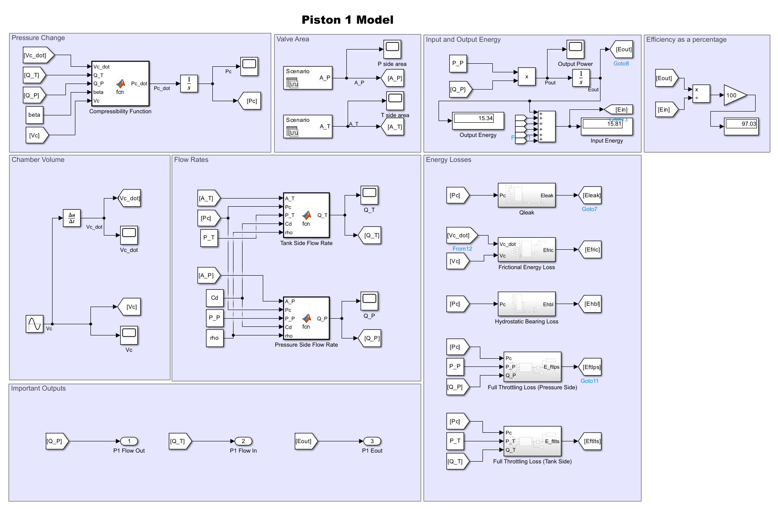

**Figure 2** Simulink diagram for the first of nine pistons. All other pistons follow the same logic. Efficiency is 97.03% as can be seen (top right) from the figure.

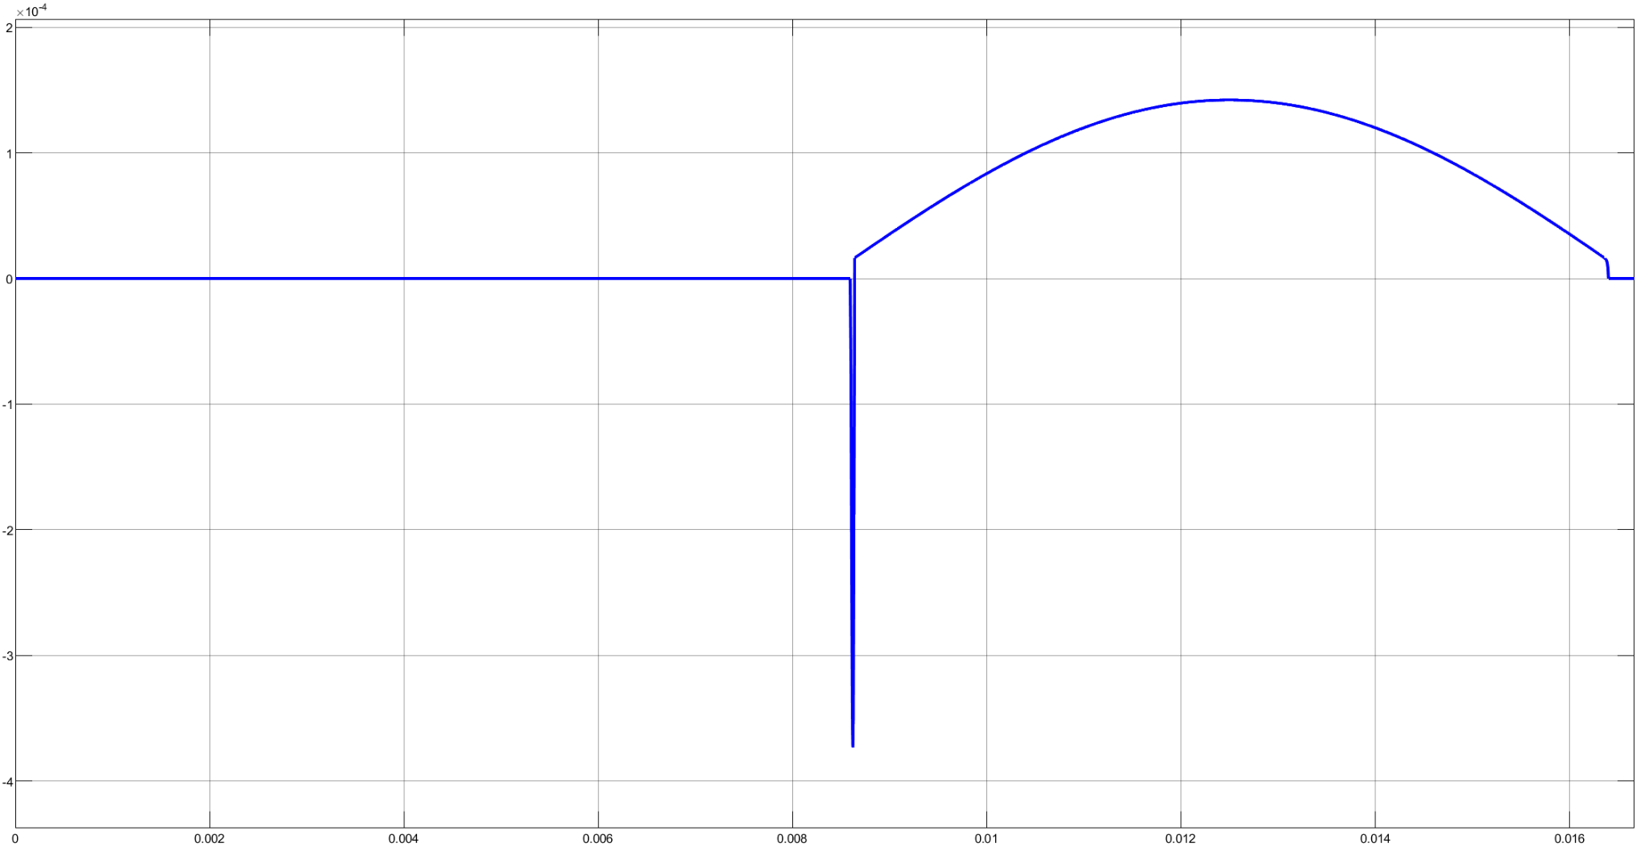

**Figure 3** Tank side flow rate for piston 1.

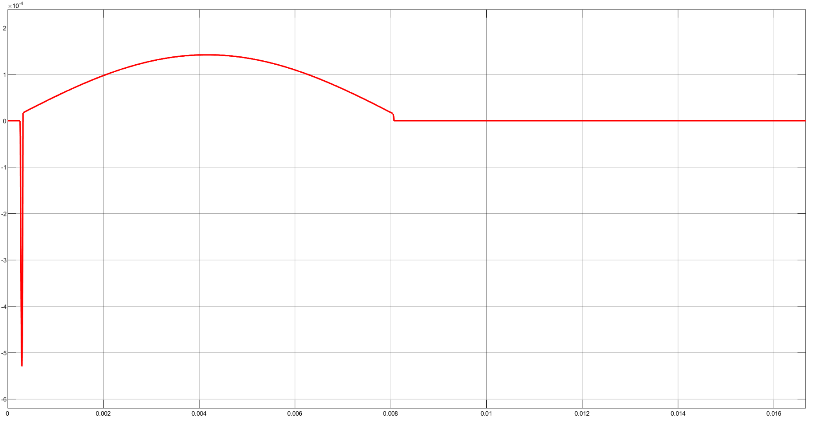

**Figure 4** Pressure side flow rate for piston 1.

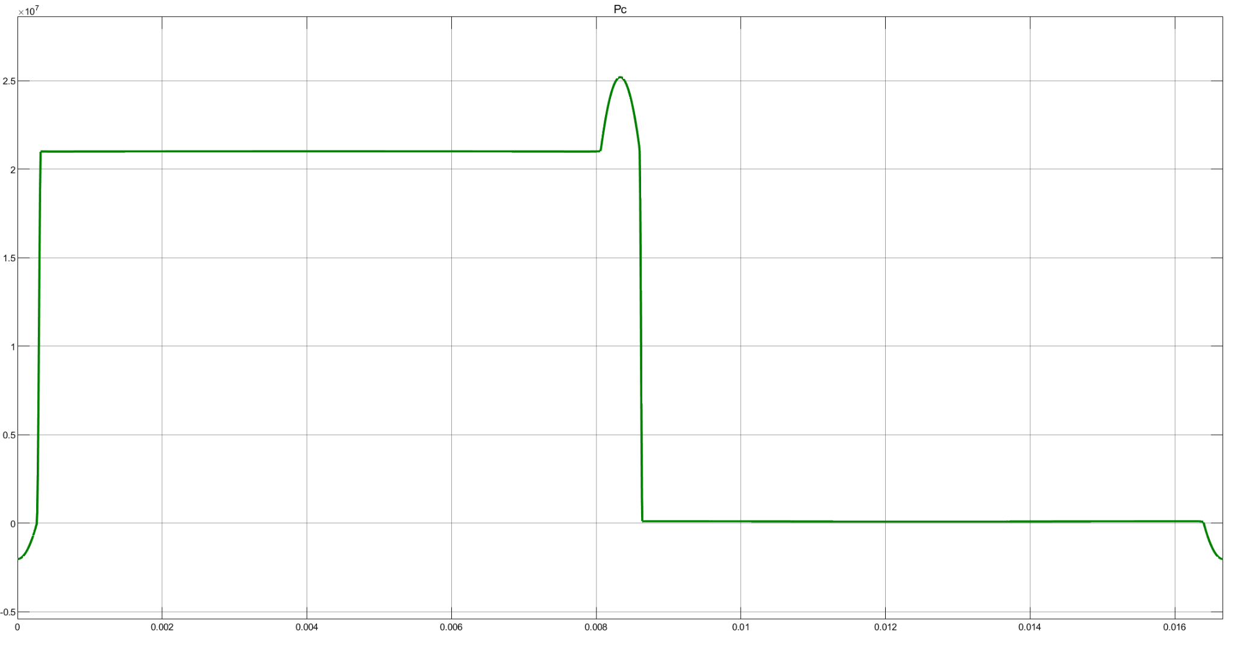

**Figure 5** Chamber pressure

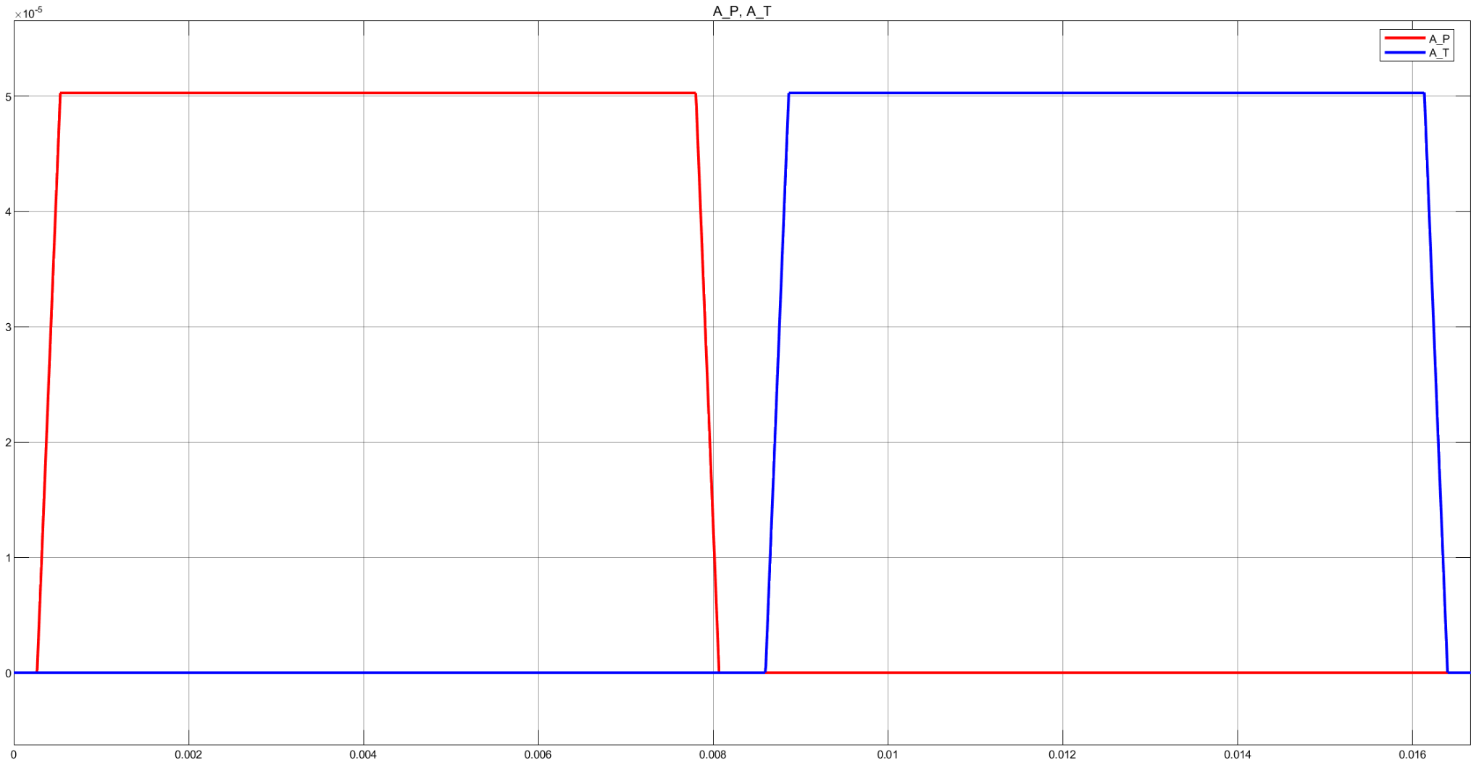

**Figure 6** Pressure side and tank side port area.

**Whole pump section:**

**Simulink diagram of the whole pump (all 9 pistons shown):**

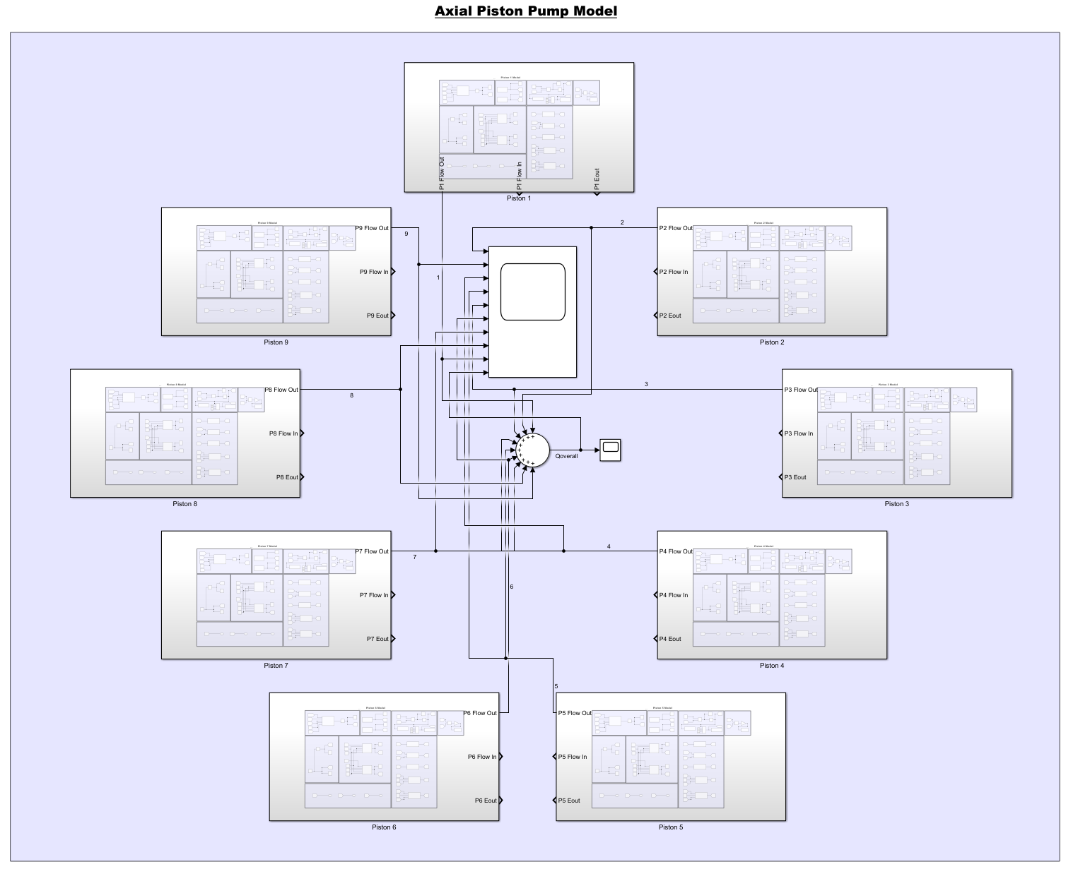

**Figure 7** Simulink diagram for the whole pump.

**Overall flow rate:**

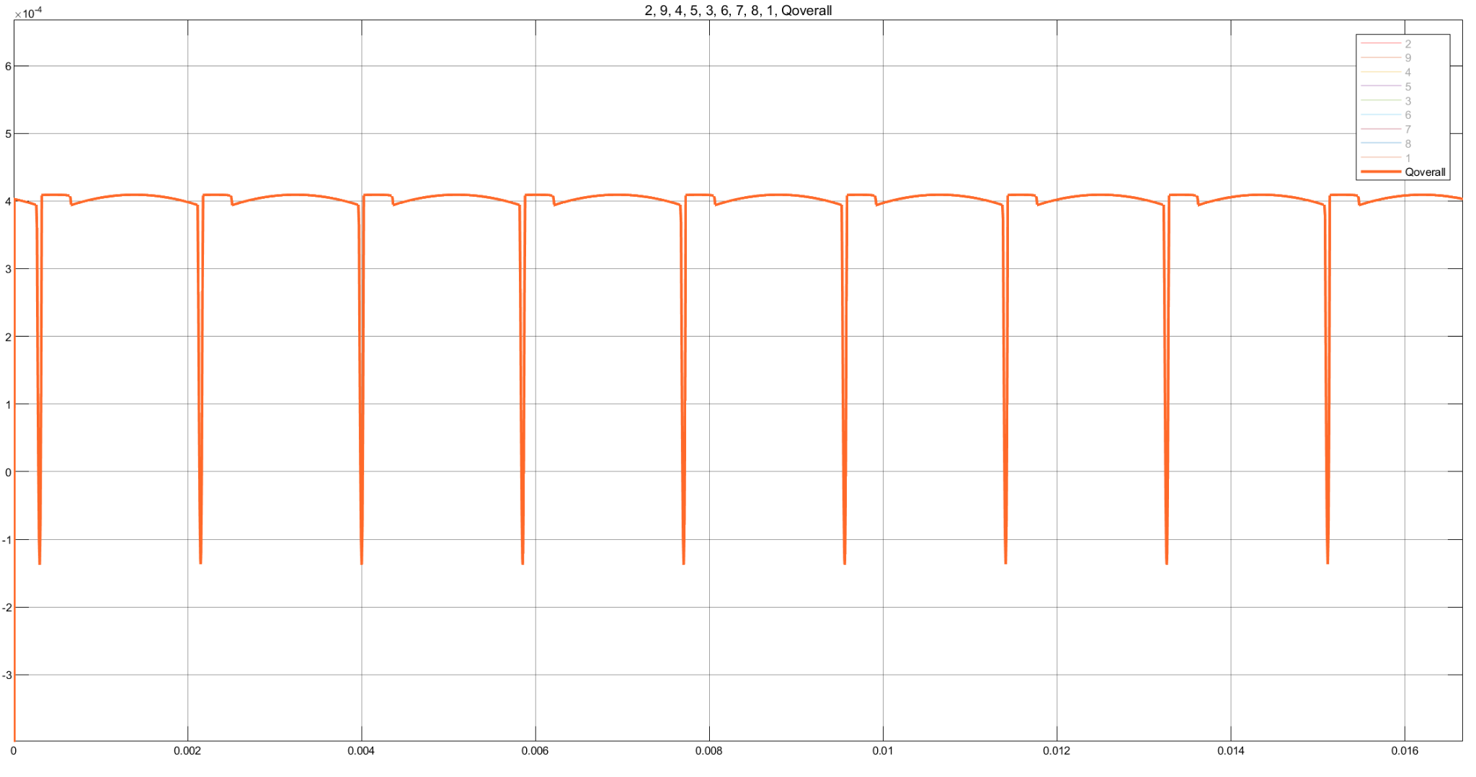

**Figure 8** Overall flow rate. The spikes are the backflow. The flow rate hovers around 4x10-4 m3/s.

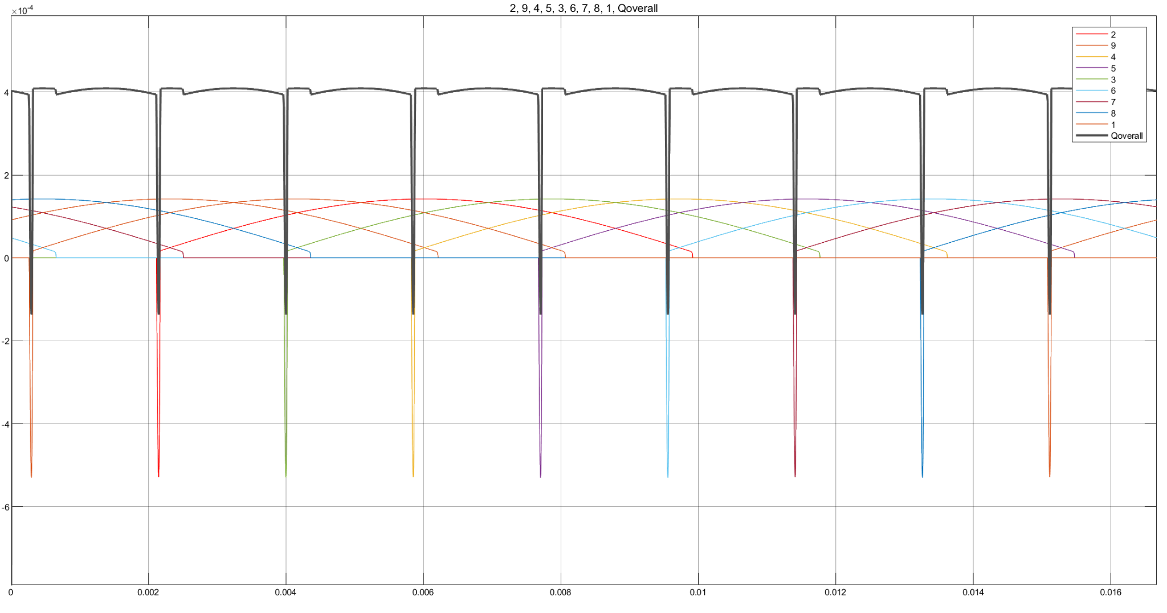

**Figure 9** Overall flow rate (grey) and the flow rates of all the 9 pistons (rainbow).

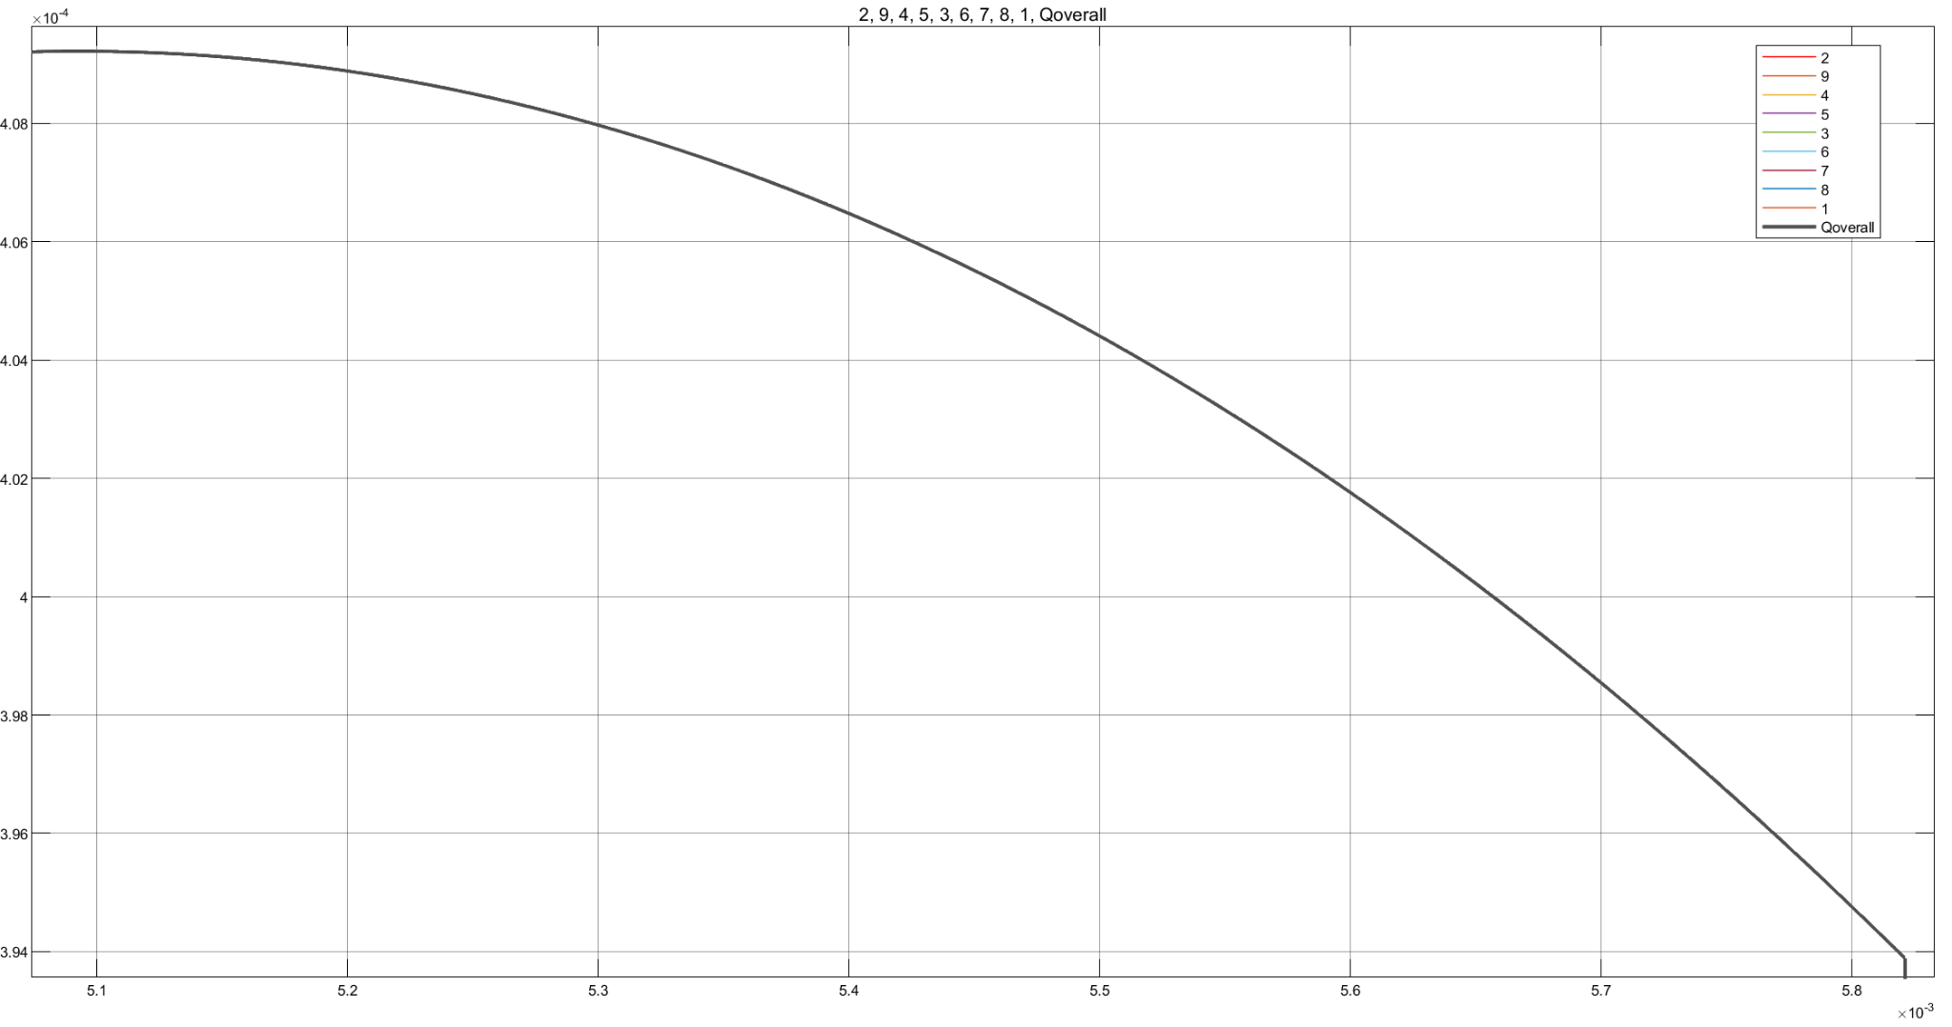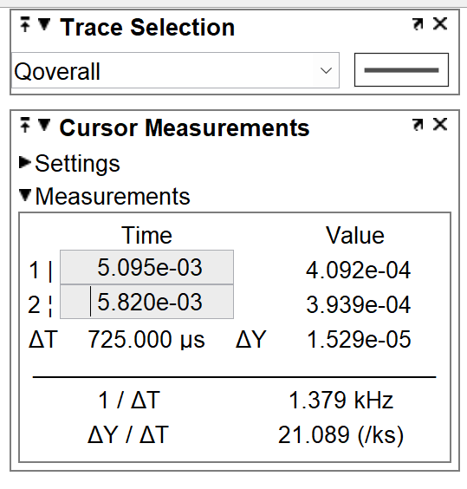

**Figure 10** Maximum and minimum flow rates.

**Flow ripple:**

* Flow ripple = 0.0381 = **3.81%** of the average flow rate.
* Fluctuation is kept less than 8% strictly.

**Sensitivity analysis:**

Assuming the major pump dimensions like piston diameter, barrel diameter, etc. to be fixed, the parameter that has a major impact on efficiency is the clearance between the piston and barrel. The clearance is in both the leakage and viscous friction loss. But it increases the leakage and decreases the viscous friction. So, there is a tradeoff between the two. Trying various values in increments of 10 um, starting from 10 um, we found 80 um to be the best (most efficient) option.

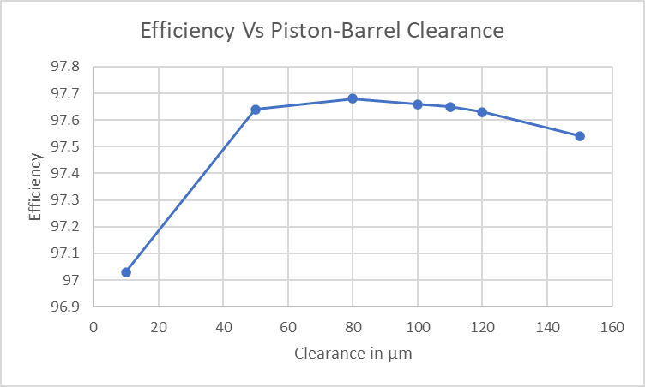

**Figure 11** Efficiency versus piston-barrel clearance. 80 mm is the highest as can be seen from the graph.

**Explanation of the figures:**

**Figure 3 (Output flow rate):**

* There is an initial, sharp drop in flow rate caused by the backflow from the pressure side to the barrel chamber.
* After that, the flow rate keeps varying in line with the sinusoidally varying chamber volume.
* Finally, the discharge port closes before the piston reaches the top dead center. This leads to an abrupt drop to zero.

**Figure 4 (Input flow rate):**

* There is an initial, sharp drop in flow rate caused by the backflow to the tank from the pre-pressurized barrel chamber.
* After that, the flow rate varies in line with the sinusoidally varying chamber volume.
* Finally, similar to the output flow rate, the discharge port closes before the piston reaches the bottom dead center. This leads to an abrupt drop to zero.

**Figure 5 (Chamber pressure):**

* At the bottom dead center, the pressure is low because the piston kept retracting after the intake port is closed from the previous cycle. This is made so that the discharge and intake ports are always kept apart.
* As the piston starts to accelerate towards the top dead center the pressure in the chamber spikes rapidly to slightly above system pressure.
* Then the discharge port quickly but linearly closes before the piston reaches the top dead center. This leads to a further increase in pressure in the vacuum. The barrel chamber must be designed to sustain this maximum pressure.
* Eventually, the intake port opens and the fluid in the chamber depressurizes quickly to a pressure below the tank pressure.
* At the end of the intake stroke, the intake port closes before the piston ever reaches the bottom dead center and this will further decrease the pressure and the cycle is repeated.
* However, the pressure should not go below zero when working with absolute pressure. That has no physical meaning unless we have antimatter or a black hole in the pump. It is a matter that needs to be addressed.

**Figure 8 (Overall output flow rate):**

* Finally, the overall output pump flow rate is generated by superimposing the output flows from each piston that are out of phase with each other by 2/(the number of pistons). This is the result of the basic architecture of axial piston pumps and helps to improve the flow ripple and decrease it to a mere 8% variation of the average flow rate.

**Appendix:**

**Initialization function:**

**%% Outlet**

% Parameters

d_cyl = 8e-3; % Diameter of each piston

r_p = 20e-3; % Piston pitch radius

A_cyl = 0.25 * pi * d_cyl^2; % Area of each piston

omega_rpm = 3600; % Rotational speed of pump

omega = (2*pi/60) * omega_rpm; % Angular speed of pump

beta = 1.6e9; % Bulk Modulus

P1 = 21e6; % Outlet pressure

S = 15e-3; % Stroke length

Cd = 0.6; % Coefficient of discharge

rho = 870; % Density

P_T = 101325; % Tank pressure

P_P = 21e6; % System pressure

c = 10e-6; % Piston-barrel clearance

meu = 0.1; % Steel-steel (lubricated) coefficient of friction

r2_r1 = 1.6; % Slipper radii ratio

r1 = d_cyl/2;

do = 0.1e-3; % Slipper orifice opening

% Time parameters

theta_cycle = 2 * pi;

t_cycle = theta_cycle / omega;

theta_t = 2 * asin(d_cyl/(4*r_p));

t_t = theta_t/omega;

theta_d = theta_cycle/2 - 2 * theta_t;

t_d = theta_d/omega;

% Calculated parameters

Vdisp = 0.25 * pi * d_cyl^2 * S;

Vo = Vdisp;

**Reference:**

[1] Fundamentals of Fluid Power Control by John Watton, 2009